080712_001J Assembly Drawing

07/30/15

Pin 1, + Pin of Capacitor, Orientation of diode – in Orange

TOP

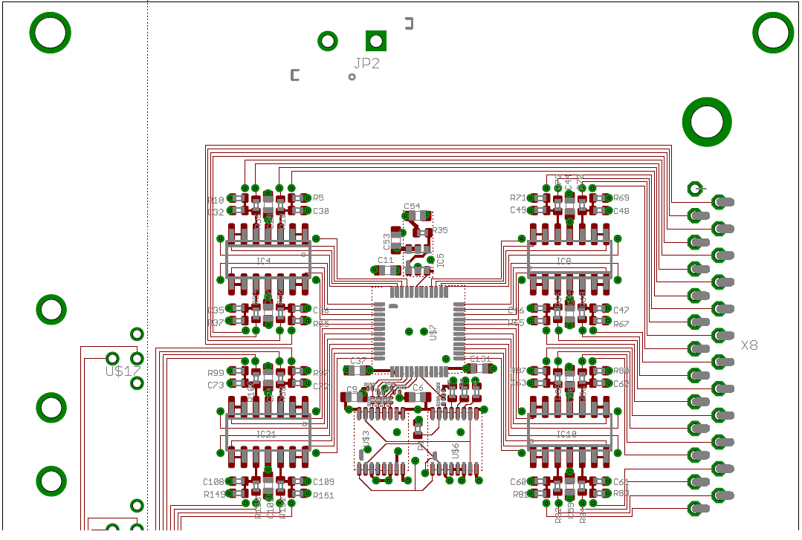

**o**

**o**

**o**

**o**

**o**

**o**

**o**

**o**

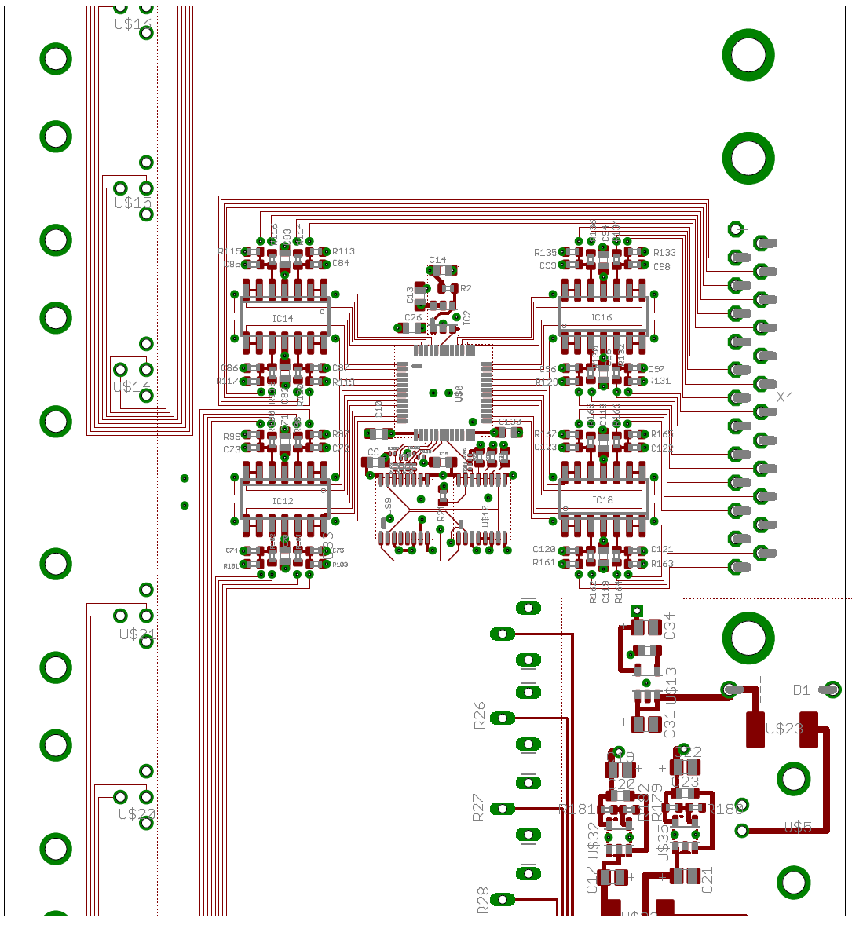

**o**

**+**

**+**

**+**

**+**

**|**

**+**

**+**

**o**

**o**

**o**

**o**

**o**

**o**

**o**

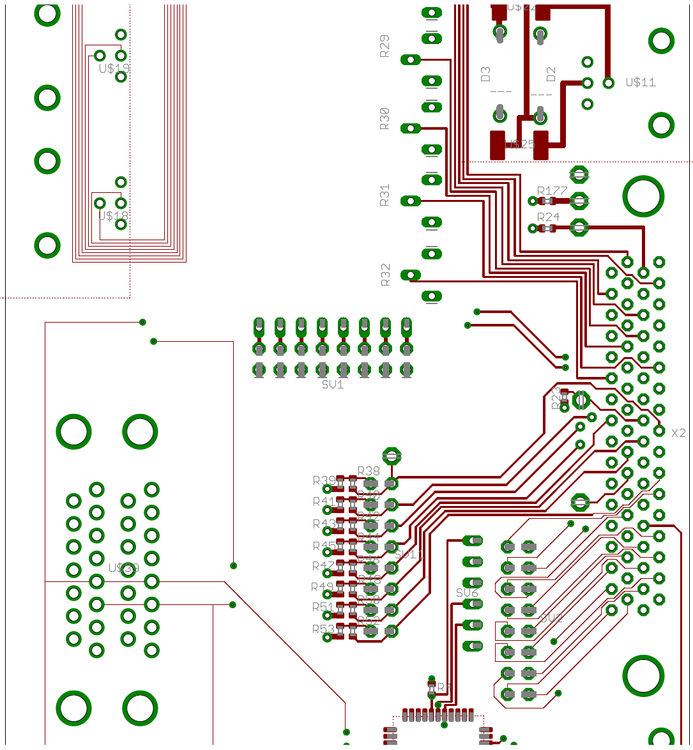/

**____**

**____**

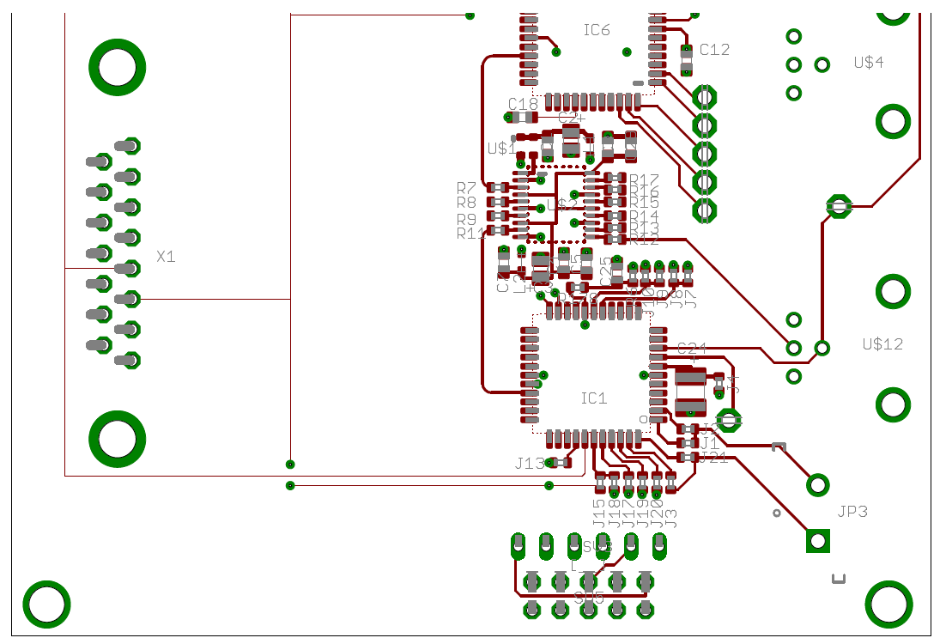

**+**

**o**

**o**

Bottom

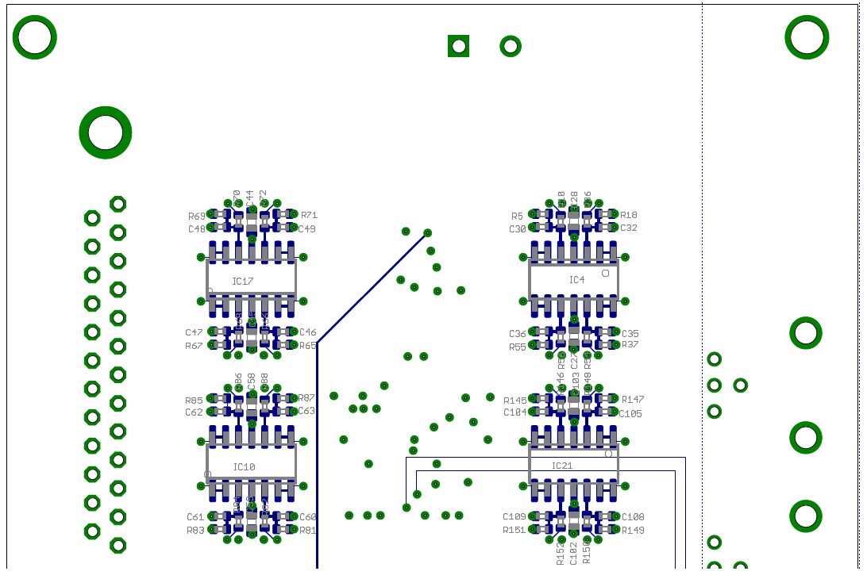

**o**

**o**

**o**

**o**

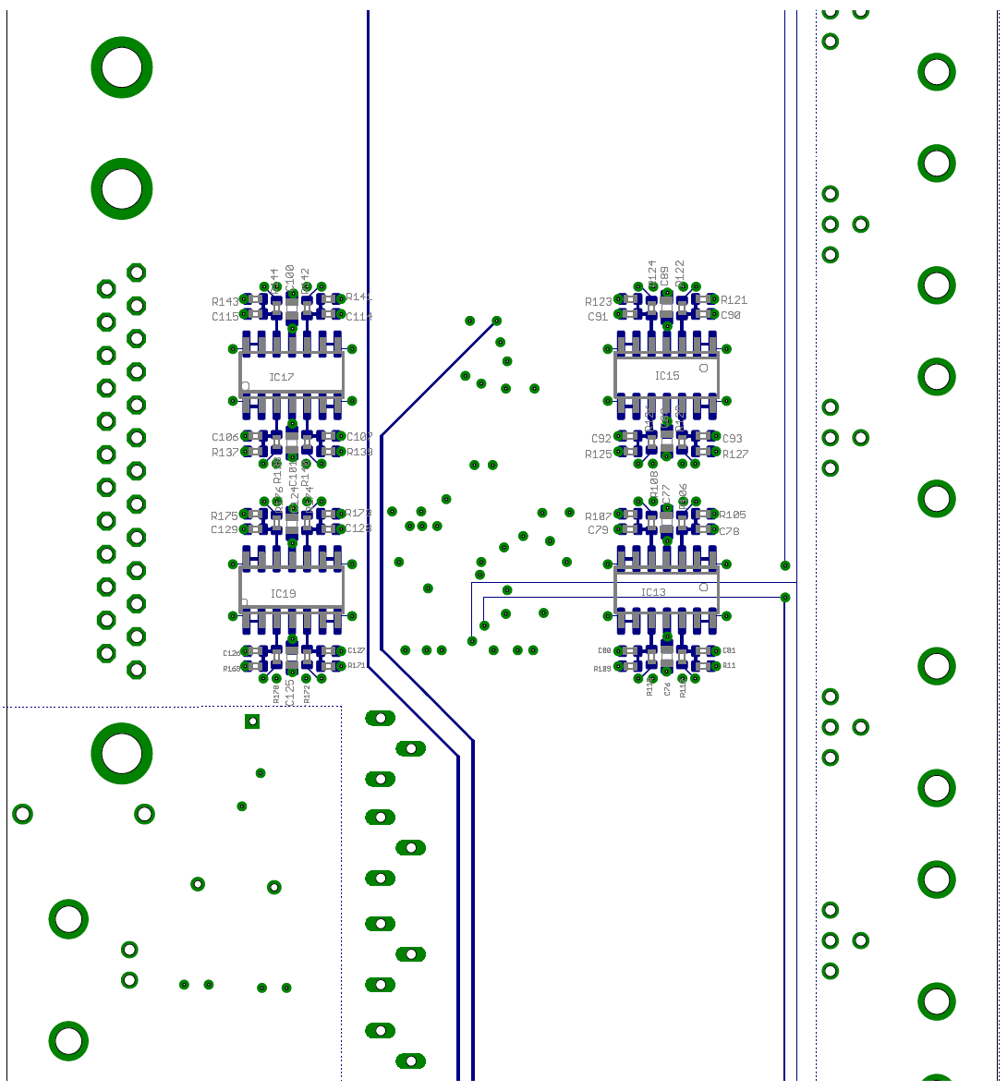

**o**

**o**

**o**

**o**

